Name of the article
A. A. Author (orcid: 0000-0000-0000-0000)¹, B. B. Coauthor^{1,2}, and C. C. Coauthor³
¹ Name of Department, Name of Institute, City, Country
²Name of Department, Name of Institute, City, Country
³Name of Department, Name of Institute, City, Country
Abstract
Paper title should be written in uppercase and lowercase letters, not all uppercase. All authors of the paper must be listed with their affiliations and the corresponding author. Also, if possible, please indicate the authors’ orcid numbers as in the example above. The abstract should be a concise statement of the problem, approach, findings, and implications of the work described within a single paragraph. It should clearly state the paper’s contribution to the field. Define all symbols used in the abstract. Do not cite references in the abstract. The abstract consists of no more than 250 words. Add keywords below. Use Contents section if the number of pages is more than 30.
Keywords: keyword1, keyword2, … (no more than 6 terms)

Contents
1. Introduction 2
2. Section name 2
2.1. Subsection name 2
2.1.1. Subsubsection name 2
2.2. Figures and Tables 2
2.3. Formatting of Mathematical Components 3
3. Materials and methods 3
4. Results 3
5. Discussion 3
6. Conclusion 3
7. Acknowledgements 3
8. Author contributions 3
9. Funding 3
10. Data availability statement 3
11. Conflicts of interest 4
Appendix A. Name of appendix 4
Appendix B. Name of appendix 4

1. Introduction
The first section of the paper is usually an introduction section, in which the background, the topic and aims are described. The main results and principal conclusions should be highlighted in this section.

2. Section name
Please use the styles and formats defined in this manuscript for titles, texts, figures and tables. Specific examples are as follows.

2.1. Subsection name
Subsection text.

2.1.1. Subsubsection name
Sections, subsections and subsubsections have different intervals before and after their names – for sections 12 pt and 12 pt, for subsections 10 pt and 10 pt, for subsubsections 6 pt and 6 pt respectively. Each new paragraph indentation is 1 cm. Line spacing in paragraphs is single. The font size of the main text is 12 pt.

2.2. Figures and Tables
Figures, schemes, and charts, along with their captions, should be placed in the text where they are first mentioned and numbered consecutively with Arabic numbers. The figure caption should be placed below the picture. The font size of figure caption is 11 pt. The space before and after the picture and its caption is 12 pt.
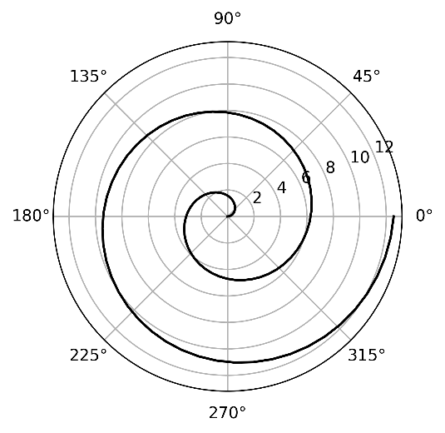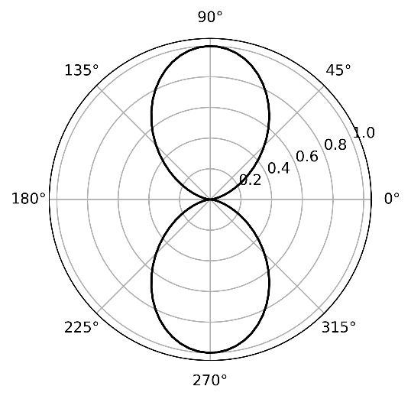
- (b)
Figure 1. If there are multiple panels, please give a detailed description: (a) Description of what is contained in the first panel; (b) Description of what is contained in the second panel. A caption on a single line should be centered.
Table 1. Table caption.
1 | 2 | 3
4 | 5 | 6
7 | 8 | 9ª
ª Tables may have a footer.
Tables should be placed in the main text near to the first time they are cited and numbered consecutively with Arabic numbers. The table caption should be placed above the table. The font size of table caption is 11 pt. The space before and after the table and its caption is 12 pt. A caption on a single line should be centered.

2.3. Formatting of Mathematical Components
The authors are encouraged to use either the Microsoft Equation Editor or the MathType (http://www.mathtype.com) for equations. This is an example of an equation:
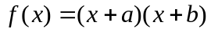 (1)

3. Materials and methods
Text.

4. Results
Text.

5. Discussion
Text.

6. Conclusion
Text.

7. Acknowledgements
Text.

8. Author contributions
A.A. Author: Conceptualization, Methodology, Software; B.B. Coauthor: Data curation, Writing, Original draft preparation; CC: Visualization, Investigation; DD: Supervision; CC: Software, Validation; FF: Writing, Reviewing and Editing.

9. Funding
This research was funded by

10. Data availability statement
Authors are encouraged to share the research data supporting the findings presented in this article. Please provide details of where the data can be accessed, including links to publicly available repositories or supplementary materials, where applicable. If no new data were generated or analysed, or if the data cannot be shared due to legal, ethical, privacy, confidentiality, or other restrictions, a statement is still required. For examples, please see the Data Availability section at https://nsr.jinr.int/journalpolicies#data-availability-statement

11. Conflicts of interest
The authors declare no conflicts of interest. Any financial, professional, personal, or other relationships that could be perceived as influencing the work must be disclosed.

Appendix A. Name of appendix
The appendix is an optional section that can contain details and data supplemental to the main text. All appendix sections must be cited in the main text. Pictures, tables and equations should be numbered consecutively with appendix letter and Arabic number as follows:
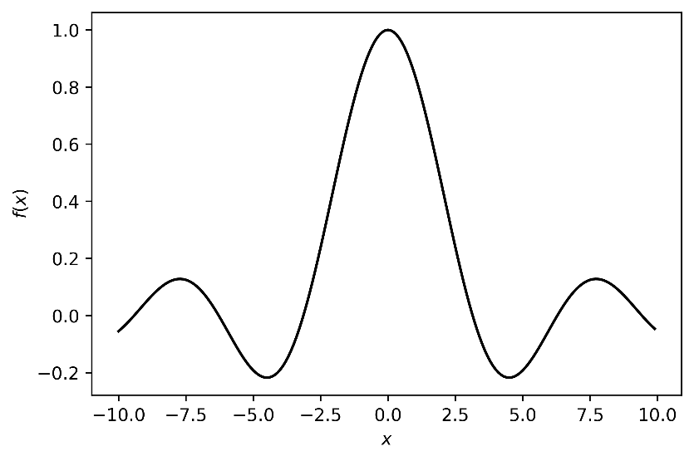
Figure A.1. Figure caption.
Table A.1. Table caption.
1 | 2 | 3
4 | 5 | 6
7 | 8 | 9

(A.1)

Appendix B. Name of appendix
References must be numbered in order of appearance in the text (including citations in tables and legends) and listed individually at the end of the manuscript. We recommend preparing the references with a bibliography software package to avoid typing mistakes and duplicated references. Include the digital object identifier (DOI) for all references where available.
Citations and References in Appendix sections are permitted provided that they also appear in the reference list here.
In the text, reference numbers should be placed in square brackets [ ], and placed before the punctuation; for example [1], [1–3] or [1,3]. The font size of references is 11 pt.
References
- A. A. Author, B. B. Coauthor, Title of the article, Journal Name Volume (Year) Page range. doi:doi_number.
- A. A. Author, The title of the book, 3rd Edition, Vol. 4, The name of the publisher, 1993, Ch. 8, pp. 201–213.
- A. A. Author, B. B. Coauthor, Book title, 3rd Edition, Publisher, Publisher Location, Country, 2008.
- A. Editor, B. Editor (Eds.), Name of the proceedings, Vol. XX of Name of the series, Publisher, Publisher Location, Country, 2018.
- A. A. Author, B. B. Coauthor, Title of the work, in: Proceedings of the Name of the Conference, Location of Conference, Country, Date of Conference, Publisher, Publisher Location, Country, 1977, pp. 879–888.
- Title of Site, URL, accessed: Year-Month-Day.
- A. A. Author, B. B. Coauthor, Name of the user guide, City, Country, 3rd Edition, available at https://example.com/manual.pdf.
- A. A. Author, B. B. Coauthor, Title of the article in the original language in Latin (Title of the article in English), Journal Name Volume (Year) Page range, (in Language). doi:doi_number.

Corresponding author e-mail address: XXX
Corresponding author e-mail address: YYY

